**Regression Discontinuity Design**

**GitHub Link:** <https://github.com/ptorreshiguera/RDD>

***Punishment and Deterrence: Evidence from Drunk Driving* Summary**

*Punishment and Deterrence: Evidence from Drunk Driving* is a paper by Benjamin Hansen published in 2015 by the American Economic Review. The main purpose of the research is answering the question “what effect does punishment severity has on the recidivism of drunk driving?”. In other words, Hansen wants to understand the effect that punishments ––depending on different thresholds of blood alcohol content (BAC)–– have to reduce drunk driving. In order to answer the research question, Hansen uses a research design that takes up a quasi-experimental approach by using regression discontinuity.

The author uses data from administrative records from the state of Washington that on aggregate have information on 512,964 DUI BAC tests that took place between 1995 and 2011. Since in Washington there are two thresholds to categorize BAC ––where a 0.08 BAC is considered DUI and a BAC that exceeds 0.15 is considered aggravate DUI––. the severity of punishment and sanctions increases depending on the result from the BAC test but also depending on the previous number of DUI the person has. In general terms, the results from the research indicate that when punishments are more severe as a result of the BAC category they fall on, recidivism of drunk driving is reduced. Therefore, in terms of public policy, it is suggested to increase the severity of punishments along the BAC distribution in order for drunk drivers to internalize the externalities of their actions and reduce their dangerous behavior.

**Replication**

**McCrary Density Test**

In order to check if there has been manipulation in blood alcohol content, it is necessary to perform a McCrary Density Test. The first thing to do under this test is to divide the assignment variable into bins and calculate the frequency of each. Then, estimate a linear regression treating each frequency count as a dependent variable. In order to pass the McCrary Density Test there must be no jump. This means that under the null hypothesis, the density must be continuous at the cutoff point; while under the alternative hypothesis, the density has an increase at the kink. Therefore, if H0 is rejected, then the discontinuity in the density could be sign of manipulation of the running variable around the cutoff.

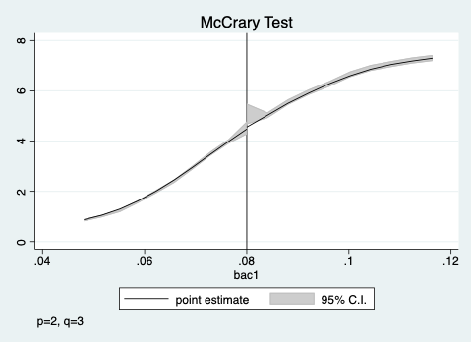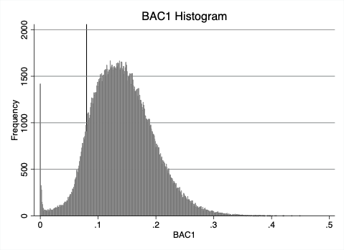

Figure 1: McCrary Test Figure 2: Replicate of Figure 1. BAC Distributions

Doing the McCrary density test, the default result calculates a p-value of 0.0276. This means that the null hypothesis is rejected at a 5% significance level. Therefore, there is evidence to say that there was manipulation of BAC 1 around the cutoff of 0.08. These results differ from those that Hansen finds. Now, if the test is estimated both with and without bias correction, then the version without using the bias correction will calculate the same p value that Hansen gets from his research; this is 0.5936. Under this p-value we fail to reject the null hypothesis, which means there is no evidence of manipulation around this cutoff. Nonetheless, it is better to estimate results using bias correction.

**Check for covariate balance**

Table 1: Table 2 Replicate–– Regression Discontinuity Estimates for the Effect of Exceeding BAC Thresholds on Predetermined Characteristics.

|  |  |  |  |  |
| --- | --- | --- | --- | --- |
|  | (1) | (2) | (3) | (4) |
| VARIABLES | Male | White | Age | Accident |
|  |  |  |  |  |
| D | 0.0307*** | 0.00271 | -7.787*** | -0.219*** |
|  | (0.00750) | (0.00653) | (0.215) | (0.00682) |
| bac1 | 0.218* | 0.154 | -56.36*** | -1.540*** |
|  | (0.112) | (0.0980) | (3.223) | (0.0977) |
| bac1D | -0.311*** | 0.0170 | 83.40*** | 2.656*** |
|  | (0.114) | (0.0994) | (3.268) | (0.0995) |
| Constant | 0.773*** | 0.835*** | 38.57*** | 0.201*** |
|  | (0.00678) | (0.00595) | (0.197) | (0.00622) |
| Mean  Controls | 0.7895115  No | 0.8615899  No | 34.95732  No | 0.1472935  No |
| Observations | 214,558 | 214,558 | 214,558 | 214,558 |
| R-squared | 0.000 | 0.001 | 0.013 | 0.021 |

Robust standard errors in parentheses

*** p<0.01, ** p<0.05, * p<0.1

By estimating the model using demographic characteristics and accident covariates as dependent variables, we can replicate table 2 panel A. The results are different to those estimated by Hansen. In this case, results indicate that for Male, Age and Accident we reject the null hypothesis. This means that predetermined characteristics are related to the BAC cutoffs for DUI. However, the results for White covariate fail to reject the null, which means that this predetermined characteristic is the only covariate unrelated to BAC cutoffs for DUI. Therefore, the only covariate balanced at the cutoff is White.

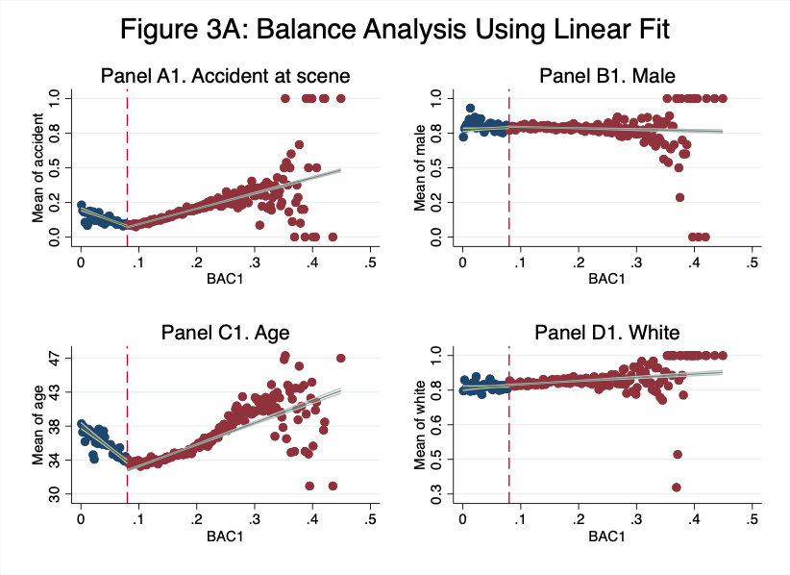

**Balance Analysis**

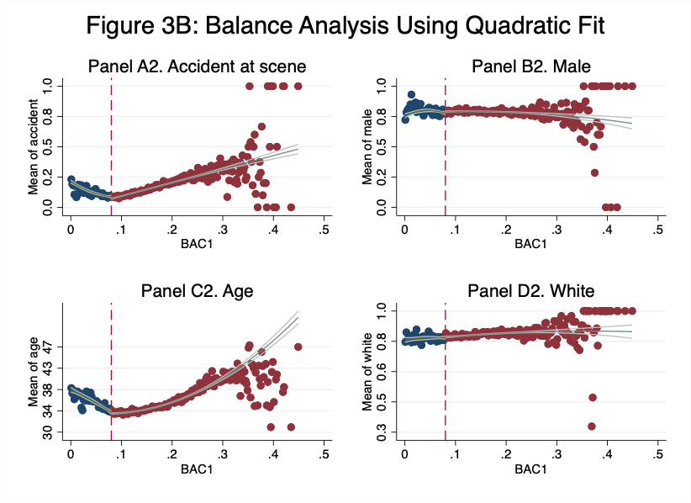

Figures 3A and 3B: replicates of Figure 2. BAC and Characteristics.

Results from figures 3A and 3B are congruent with the results from the covariate balance check in table 2. We can observe that covariates Age, Male and Accident present significant jumps at the cutoff, while White is the only covariate that does not present abrupt jumps. Figure 2 from Hansen’s paper only estimates balance analysis using linear fit. For this case, the replicates show similar trends to those calculated by Hansen, especially White covariate that shows a very similar trend and no jump. Despite following similar trends to the original estimation, Male covariate in Hansen’s paper shows a very marked jump, while the linear fit replicate is more continuous. Also, Age and Accident covariates show jumps in the replicate while in the paper is shown the opposite. This can be due to the fact that our sample differs from the one used by Hansen, which would also explain the difference between the scales from the original graphs and the replicates. Finally, in terms of fit, Age and Accident covariates seem to have a better linear fit while Male and White have better quadratic fits.

**Regression Discontinuity Estimates**

Table 2: Table 3 Replicate –– Regression Discontinuity Estimates for the Effect of Exceeding the 0.08 BAC Threshold on Recidivism

|  |  |  |  |
| --- | --- | --- | --- |
|  | (1) | (2) | (3) |
| VARIABLES | recidivism | recidivism | recidivism |
| *Panel A. BAC* ∈ [0.03, 0.13] |  |  |  |
| DUI | -0.0273*** | -0.0591*** | 0.113 |
|  | (0.00403) | (0.0152) | (0.0843) |
| bac1 | 0.321*** | -0.0429 | 2.902* |
|  | (0.0748) | (0.187) | (1.637) |
| bac1D |  | 0.438** | -4.210** |
| bac1sq |  | (0.204) | (2.111)  -24.72*  (13.74) |
| bac1Dsq |  |  | 32.73** |
| Constant  Mean  Controls | 0.0853***  (0.00672)  0.1069392  Yes | 0.109***  (0.0131)  0.1069392  Yes | (15.10)  0.0262  (0.0473)  0.1069392  Yes |
| Observations | 89,967 | 89,967 | 89,967 |
| R-squared  *Panel B. BAC* ∈ [0.055, 0.105]  DUI  bac1  bac1D  bac1sq  bac1Dsq  Constant  Mean  Controls  Observations  R-squared | 0.004  -0.0219***  (0.00558)  0.188  (0.201)  0.0862***  (0.0154)  0.1052239  Yes  46,957  0.004 | 0.004  -0.0643*  (0.0350)  -0.196  (0.383)  0.547  (0.499)  0.113***  (0.0278)  0.1052239  Yes  46,957  0.004 | 0.004  0.371  (0.422)  6.167  (8.120)  -10.52  (10.61)  -46.06  (58.75)  71.27  (69.21)  -0.104  (0.278)  0.1052239  Yes  46,957  0.004 |

Robust standard errors in parentheses

*** p<0.01, ** p<0.05, * p<0.1

Table 2 replicates table 3 column 1 from Hansen’s paper. It includes both panel A and B. The estimated equation uses recidivism as the dependent variable where panel A uses a bandwidth from 0.03 to 0.13, while panel B has a narrower bandwidth from 0.055 to 0.105. The first column uses bac1 linearly; second column uses bac1 linearly and the interaction with cutoff; and the third column uses the previous variables and includes bac1 quadratically and its interaction with the cutoff. All 3 regressions include Accident, Age, White and Male as covariates and use heteroskedastic robust standard errors.

The results from the replicate show the estimated effect of having BAC1 above the 0.08 threshold on recidivism. Both Panel A and Panel B for the first estimated model show that having a BAC1 over 0.08 reduces the probability of recidivism by around 2 percentage points; these results are significant at the 1% level. For the second model, results from panel A are also significant at the 1% level and show that BAC1 above the 0.08 threshold reduce recidivism by 5.91 percentage points. As for panel B, results from the second model also evidence that BAC1 above the threshold reduce recidivism by 6.43 percentage points; however, these are only significant at the 10% level. Results from the third model differ from the others and are not significant at any level. This means that the quadratic transformation is not showing the impact that being above the threshold has over recidivism. Therefore, the results from the estimates in column 1 and 2 are consistent with those found by Hansen since they find the same relationship between BAC above the threshold and recidivism. However, they differ in magnitude since the change in recidivism is greater in the replicates than in the original model. This can be due to the difference between samples used in the paper and in the replicate.

**BAC and Recidivism**

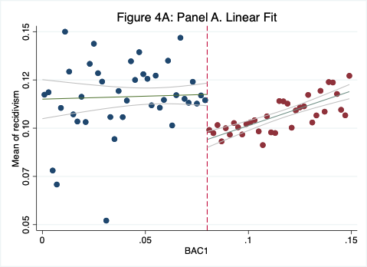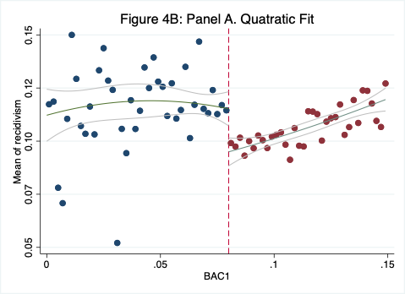

Figures 4A and 4B: Replicates of Figure 3. BAC and Recidivism

Figures 4A and 4B present replicates for Hansen’s Figure 3. Both graphs are plots of means of recidivism in bins of 0.002 in width and use observations with less than 0.15 BAC1. Figure 4A uses a linear fit. The first interval goes from 0 to the threshold of 0.08, and the second interval goes from the threshold to a 0.15 BAC1. It is evident from the graph that there is a drop in recidivism at the 0.08 threshold. This is consistent with the results found by Hansen. Therefore, the graph is telling that an increase in the severity of sanctions at the threshold is being an effective measure to reduce drunk driving. On the other hand, figure 4B uses a quadratic fit, although Hansen only uses the linear fit. Like in figure 4A, the first interval goes from 0 to the threshold of 0.08, and the second interval goes from the threshold to a 0.15 BAC1. It is also evident from the graph that there is a drop in recidivism at the 0.08 threshold. Thus, both figures are indicating that an increase in the severity of sanctions at the threshold is being an effective measure to reduce drunk driving; which means that BAC1 over the 0.08 threshold is related with lower recidivism. Finally, comparing both graphs, it seems that the linear fit is the most accurate between the two.